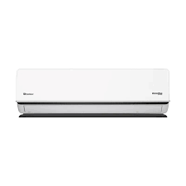

***pel auto  
 Air Conditioner***

* **Color:**white
* **Available:**in stock
* **Dimension:**1641*595*600
* **Size:**19
* **Old Price:**~~Rs535,000.00~~
* **New Price:**Rs 435,000.00